**JAVA**

**Q1**

a) Define the terms with example

i) Class

ii) Object

b) Enlist any two access specifier with syntax.

c) Give a syntax to create a package and accessing package in

java

d) Give a syntax of following thread method

i) Notify ( )

ii) Sleep ( )

e) Give a syntax of 〈param〉 tag to pass parameters to an applet.

f) Define stream class and list types of stream class.

g) Give use of garbage collection in java. a) Enlist any two logical operators and two bitwise operators.

b) Define constructor.

c) Write down the syntax of array declaration, initialization.

d) List out different ways to access package from another package.

e) Differentiate between starting thread with run( ) method and

start( ) method.

f) State the classes that can an applet extend.

g) Give syntax to open a file using Inputstream class.

a) Enlist the logical operators in Java.

b) Give the syntax and example for the following functions

i) min ()

ii) Sqrt ()

c) Define the interface in Java.

d) Enlist any four inbuilt packages in Java.

e) Explain any two methods of File Class.

f) Write syntax of elipse.

g) Enlist any four compile time errors.

a) Define constructor. List its types.

b) Define class and object.

c) List the methods of File Input Stream Class.

d) Define error. List types of error.

e) List any four Java API packages.

f) Define array. List its types.

g) List access specifiers in Java.

a) List any eight features of Java.

b) State use of finalize( ) method with its syntax.

c) Name the wrapper class methods for the following:

(i) To convert string objects to primitive int.

(ii) To convert primitive int to string objects.

d) List the types of inheritances in Java.

e) Write the syntax of try-catch-finally blocks.

f) Give the syntax of < param > tag to pass parameters to an applet.

g) Define stream class. List its types.

a) Explain following terms related to Java features.

i)Object Oriented

ii) Complied and interpreted.

b) Differentiate between Input stream class and Reader class. 4

c) Explain any two logical operators in java with example. 4

d) Thread Life Cycle Thread has five different states throughout its life.

a)Explain inheritance and polymorphism features of Java.

b)Write any two methods of array list class with their syntax.

c)Why java became platform independent language? Explain.

d)Write a program to input name and balance of customer and thread an user defined exception if balance less than 1500.

a) Define throws & finally statements with its syntax and example. 4M

b) Which are the restrictions present for static declared methods? 4M

c) Explain any 4 features of java programming

(d) Explain how interface is used to achieve multiple Inheritance in Java.

**Q2**

a) Describe type casting in java with example.

b) Differentiate between string and string buffer class

(any four points)

c) Write a program to create a user defined exception in java.

d) Write a program for reading and writing character to and from

the given files using character stream classes. a) Write a program to display ASCII value of a number 9.

b) Write a program to sort the elements of an array in ascending

order.

c) Define Thread. Draw life cycle of Thread.

d) Write a program to read a file and then count number

of words.

1. Explain any four features of Java.
2. b) Write a Java program to copy the content of one file into another.
3. c) Write the difference between vectors and arrays. (any four points)
4. d) Explain exception handling mechanism. w.r.t. try, catch, throw and finally
5. a) Differentiate between String and String Buffer.
6. b) Define a class circle having data members Pi and radius. Initialize and display values of data members also calculate area of circle and display it.
7. c) Define exception. State built-in exceptions.
8. d) Write a syntax and example of
9. (i) drawRect( )
10. (ii) drawoval( )
11. a) Explain the concept of platform independence and portability with respect to Java language.
12. b) Explain the types of constructors in Java with suitable example.
13. c) Explain the two ways of creating threads in Java.
14. d) Distinguish between Input stream class and output stream class.
15. Define a class person with data member as Aadharno, name,

Panno implement concept of constructor overloading. Accept

data for 5 object and print it.

b) What is package? How do we create it? Give the example to

create and to access package.

c)Give the syntax of following methods of graphics class. Explain

their use with suitable program:

(i) drawRoundReel( )

(ii) drawPolygon( )

(iii) drawOval( )

(iv) drawstring( )

(Note: Solution is given for drawRoundRect() method)

1. Write a java program to implement visibility controls such as public, private,

protected access modes. Assume suitable data, if any.

b) With proper syntax and example explain following graphics methods:

1) SetColor( )

2) SetForeGround( )

3) getFont( )

4) setSize( )

2. Attempt any TWO of the following: 16Marks

(a) Write a java program to copy the content of the file “file1.txt” into new file

“file2.txt”.

(b) Write a java program to implement multilevel inheritance with 4 levels of hierarchy. 8M

Ans: {{**Note:-Any other example can be considered **}}

(c) Define applet. Write a program to create an applet to display message “Welcome to

java applet”.

d) Define a class ‘Book’ with data members bookid, bookname and price.

Accept data for seven objects using Array of objects and display it.

b) What is interface? Describe its syntax and features.

a) Write a program to create a vector with seven elements as

(10,30,50,20,40,10,20). Remove elements 3rd and 4th position. Insert new

elements at 3rd position. Display original and current size of vector.

b) What is package in Java? Write a program to create a package and import the package in another class.

c) Write syntax and example of i)Draw Poly ii)Draw Rect iii)Filloval iv)Draw Arc()

**Q3**

a) Write a program which displays functioning of ATM machine,

(Hint : Withdraw, Deposit, Check Balance and Exit)

b) Differentiate between method overloading and method overriding.

c) Explain applet life cycle in detail.

d) Differentiate between Byte Stream Class and Character Stream

Class. (Any four points) a) Write a Java program to find out the even numbers from 1 to 100 using for loop.

b) Explain any four visibility controls in Java

. c) Explain single and multilevel inheritance with proper example.

d) Write a java applet to display the following output in Red color. Refer Fig No. 1. Fig No.

1. Explain the following classes.
2. (i) Byte Stream Class
3. (ii) Character Stream Class
4. b) Explain life cycle of Applet.
5. c) Differentiate between class and interfaces.
6. d) Define type casting. Explain its types with syntax and example.
7. a) Define a class student with int id and string name as data members and a method void SetData ( ). Accept and display the data for five students.
8. b) Explain dynamic method dispatch in Java with suitable example.
9. c) Describe the use of following methods:
10. (i) Drawoval ( )
11. (ii) getFont ( )
12. (iii) drawRect ( )
13. (iv) getFamily ( )
14. d) Write a program to count number of words from a text file using stream classes.
15. Differentiate between array and Vector
16. Explain fileinputstream class to read the content of a file
17. Explain applet life cycle with suitable diagram.
18. What is use of super and final with respect to inheritance
19. Explain any four applet tag.
20. Which are the ways to access package from another package? Explain with example
21. Define a class and object. Write syntax to create class and object with an example.
22. With proper syntax and example explain following thread methods: (1) wait( )
23. (2) sleep( )
24. (3) resume( )
25. (4) notify( )
26. What is type casting? Explain its types with proper syntax and example
27. Describe following string class method with example:
    1. compareTo( )
    2. equalsIgnoreCase( )
    3. compareTo( ):
28. Syntax: intcompareTo(Object o)
29. Write a program to copy contents of one file to another. Using byte stream classes.
30. Explain method overriding with suitable example.
31. Enlist any four built in packages in java API with atleast two class name from each package
32. Write a program to check whether given number is prime or not.

**Q4**

a) Describe any four features of java.

b) Explain any four methods of vector class with example.

c) Describe interface in java with suitable example.

d) Write an applet program for following graphics method.

i) Drawoval ( )

ii) Drawline ( )

e) Enlist any four methods of file input stream class and give

syntax of any two methods. a) Explain implicit and explicit type conversion with example

in detail.

b) Write a program to show the use of copy constructor.

c) Write a program to show the Hierarchical inheritance.

d) Explain any four font methods with example.

e) Write a program to append content of one file into

another file.

a) Explain switch case and conditional operator in java with suitable example.

b) Draw and explain life cycle of Thread.

c) Write a java program to sort an 1-d array in ascending order using bubble-sort.

d) Explain how to create a package and how to import it.

e) Explain

i) drawLine

ii) drawOval

iii) drawRect

iv) drawArca) Explain switch case and conditional operator in java with suitable example.

b) Draw and explain life cycle of Thread.

c) Write a java program to sort an 1-d array in ascending order using bubble-sort.

d) Explain how to create a package and how to import it.

e) Explain

i) drawLine

ii) drawOval

iii) drawRect

iv) drawArca) Describe instance Of and dot (.) operators in Java with suitable example.

b) Explain the four access specifiers in Java.

c) Differentiate between method overloading and method overriding.

d) Differentiate between Java Applet and Java Application ( any four points)

e) Write a program to copy content of one file to another file.

1. Explain type casting with suitable example.
2. Explain following clause w.r.t. exception handling i) try ii) catch iii) throw iv) finally
3. Write a program to print sum of even numbers from 1 to 20.
4. Differentiate between Applet and Application.
5. Write a program to create an applet for displaying circle, rectangle and
6. triangle one below the other and filled them with red, green and yellow respectively.
7. Describe following methods related to vector addElement(), removeElement() and insertElementAt()
8. State & explain scope of variable with an example.
9. With syntax and example explain try & catch statement.
10. Explain applet life cycle with suitable diagram.
11. Explain byte stream class in detail.
12. Write a java program to implement following functions of string:
13. (1) Calculate length of string
14. (2) Compare between strings
15. (3) Concatenating strings
16. Write a java program to extend interface assuming suitable data.
17. Write a program to print the following output:
18. 1 1 1 1 1
19. 2 2 2 2
20. 3 3 3
21. 4 4
22. Illustrate with example the use of switch case statement.
23. Write a program to create two thread one to print odd number only and other to print even numbers.
24. What is the use of try catch and finally statement give example.
25. What is importance of super and this keyword in inheritance? Illustrate with suitable example.
26. Write a single program to implement inheritance and polymorphism in java.

**Q5**

a) Write a program to copy all elements of one array into

another array.

b) Write a program to implement the following inheritance.. 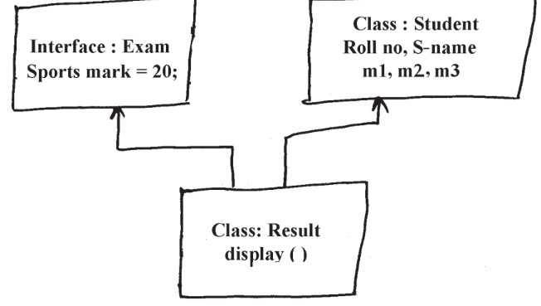

c) Write a program to print even and odd number using two

threads with delay of 1000ms after each number.

a) Explain vector with the help of example. Explain any 3 methods

of vector class.

b) Develop and Interest Interface which contains Simple Interest

and Compound Interest methods and static final field of rate

25%. Write a class to implement those methods.

c) Write a program that throws an exception called

“NoMatchException” when a string is not equal to “India”.

a) How to create user defined package in Java. Explain with an suitable example.

b) Write a Java program in which thread A will display the even numbers between 1 to 50 and thread B will display the odd numbers between 1 to 50. After 3 iterations thread A should go to sleep for 500ms.

c) What is constructor? List types of constructor. Explain paramaterized constructor with suitable example.

a) Write a program to create vector with five elements as (5, 15, 25, 35, 45). Insert new element at 2nd position. Remove 1st and 4th element from vector.

b) Define packages. How to create user defined package? Explain with example.

c) Write a program to create two threads one thread will print even no. between 1 to 50 and other will print odd number between 1 to 50.

1. Explain following terms: i) Thread priority ii) Types of Exception
2. Write a program to create two threads.so one thread will print even 8
3. Write a program to create two thread so one thread will print even numbers between 1 to 10 whereas other will print odd number between 11 to 20
4. How can parameters be passed to an applet? Write an applet to accept username in the parameter and print “Hello<username>
5. Write a java program to implement runnable interface with example.
6. Explain following methods for applet with an example:
7. (1) Passing Parameter to applet
8. (2) Embedding <applet> tags in java code.
9. Write a java program to display all the odd numbers between 1 to 30 using for loop & if statement
10. What is exception? Why the exception occurred in program? Explain with suitable example.
11. Write a program to define two thread one to print from 1 to 100 and other to print from 100 to 1. First thread transfer control to second thread after delay of 500 ms.
12. How to pass parameter to an applet? Write an applet to accept Account No and balance in form of parameter and print message “low balance” if the balance is less than 500.

**Q6**

a) Explain thread life cycle with neat diagram.

b) Write a program to generate following output using

drawline ( ) method.

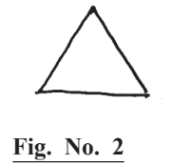

c) Explain constructor with its type. Give an example of

parameterized constructor.

a) Write a program to print the sum, difference and product of

two complex numbers by creating a class named “Complex”

with separate methods for each operation whose real and

imaginary parts are entered by user.

b) i) Explain Errors and its types in detail.

ii) Explain thread methods to set and get priority.

1. Write a program to draw a chessboard in Java Applet.
2. a) Write a Java program to count the number of words from a text file using stream classes.

b) Explain the difference between string class and string buffer class. Explain any four methods of string class.

c) Write a Java applet to draw a bar chart for the following values

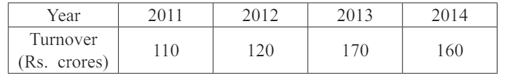

1. Explain how to pass parameter to an applet? Write an applet to accept username in the form of parameter and print “Hello ”.
2. b) Write a program to perform following task.
3. (i) Create a text file and store data in it.
4. (ii) Count number of lines and words in that file.
5. c) Implement the following inheritance.

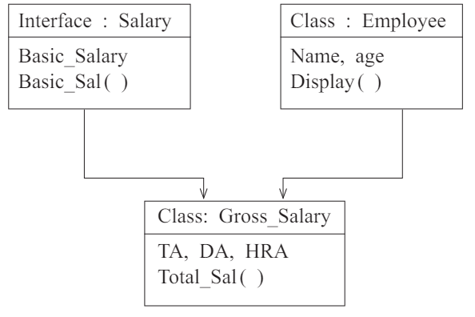

a) Explain the command line arguments with suitable example.

b) Write a program to input name and salary of employee and throw user defined exception if entered salary is negative.

c) Describe the applet life cycle in detail.

1. Demonstrate the concept of method overriding with example.
2. Write any two methods of file and file input stream class each.
3. Design an applet which displays rectangle filled with blue colour and display message as “MSBTE EXAM” in red colour below it.
4. Write a program to demonstrate multiple inheritance
5. Write a program to find greater number among two numbers using conditional operator.
6. Explain following bitwise operator with an example:
7. (1) left shift operator
8. (2) write shift operator
9. State & explain types of errors in Java
10. Enlist types of constructor. Explain any two with example.
11. How to add new class to a package? Explain with an example.
12. Explain Arrary list & Iterator methods of collections with an example
13. What is the use of wrapper classes in Java? Explain float wrapper with its methods.
14. Write a program to accept number from command line and print square root of the number
15. Write any four methods of File Input stream class give their syntax.
16. Write a applet program to set background with red colour and fore ground with blue colour
17. Describe access control specifiers with example